USER INTERFACE DESIGN
EXPERIMENT 3: Difference between CLI(Command line interface) and GUI(Graphical user interface) and VUI (voice userinterface)

NAME: GAYATHRI BOOPATHY REG NO: 240701141

Aim:
To design and implement a file renaming system using Command Line Interface (CLI), Graphical User Interface (GUI), and Voice User Interface (VUI), and compare their usability and efficiency.

REQUIREMENTS

Hardware:
- Laptop/Desktop

- Microphone

Software:
- Python 3.x

- Tkinter Library

- SpeechRecognition

- PyAudio

Command Line Interface (CLI)

A Command Line Interface allows users to interact with the system by typing commands into a terminal.

Advantages:

- Fast execution

- Low memory usage

- Suitable for advanced users

Disadvantages:

- Requires knowledge of commands

- Not user-friendly for beginners

Implementation:
The CLI program renames files using command-line arguments.

Working:
- Accepts old filename and new filename as inputs

- Uses os.rename() function

- Displays success or error messages

import os import sys

def rename_file(old_name, new_name): try:
os.rename(old_name, new_name)
print(f"File renamed from {old_name} to {new_name}") except FileNotFoundError:
print(f"Error: {old_name} not found.") except Exception as e:

print(f"An error occurred: {e}")

if name == " main ": if len(sys.argv) != 3:
print("Usage: python rename_file_cli.py <old_filename> <new_filename>") else:
rename_file(sys.argv[1], sys.argv[2])

Output:
harshavardhini@Harshas-MacBook-Air UID EX3 % python3 cli.py old.txt new.txt File renamed from old.txt to new.txt
harshavardhini@Harshas-MacBook-Air UID EX3 %

Graphical User Interface (GUI)
A GUI allows users to interact through graphical elements such as windows, buttons, and text fields.

Advantages:

- Easy to learn

- Interactive

- Reduces user errors

Disadvantages:

- Consumes more system resources

- Slower than CLI

Implementation:
The GUI application is built using Tkinter, allowing users to rename files through a graphical window.

Features:
- Input fields for old and new filenames

- Rename button

- Popup messages for success or errors

import tkinter as tk
from tkinter import messagebox import os

def rename_file():
old_name = old_filename_entry.get() new_name = new_filename_entry.get()

if not old_name or not new_name:
messagebox.showwarning("Warning", "Please enter both filenames.") return

try:
os.rename(old_name, new_name)
messagebox.showinfo("Success", f"File renamed from {old_name} to {new_name}") except FileNotFoundError:
messagebox.showerror("Error", f"File '{old_name}' not found.") except Exception as e:
messagebox.showerror("Error", f"An error occurred: {e}")

root = tk.Tk() root.title("File Renamer")
root.geometry("400x150") # makes window look professional root.resizable(False, False)

tk.Label(root, text="Old Filename:").grid(row=0, column=0, padx=10, pady=10) tk.Label(root, text="New Filename:").grid(row=1, column=0, padx=10, pady=10)

old_filename_entry = tk.Entry(root, width=30) old_filename_entry.grid(row=0, column=1)

new_filename_entry = tk.Entry(root, width=30)

new_filename_entry.grid(row=1, column=1)

rename_button = tk.Button(root, text="Rename File", bg="green", fg="white", command=rename_file)
rename_button.grid(row=2, columnspan=2, pady=15)

root.mainloop()

Output:
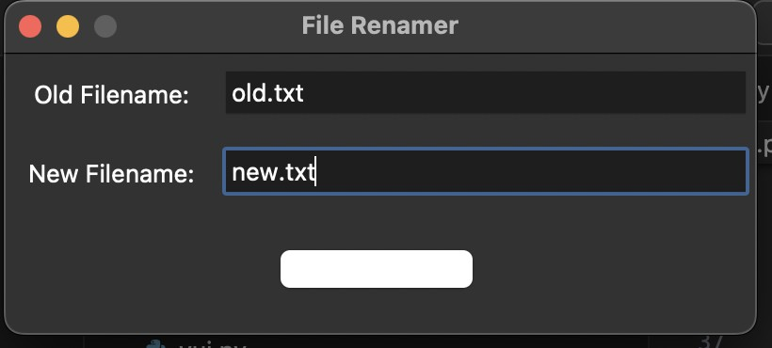

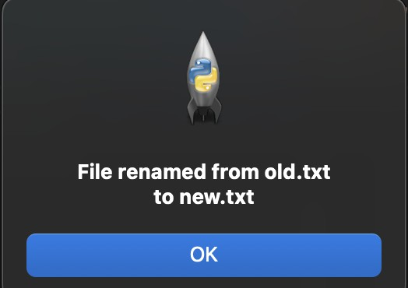

Voice User Interface (VUI)
A Voice User Interface enables interaction using voice commands and speech recognition technology.

Advantages:

- Hands-free operation

- Improves accessibility

- Natural communication

Disadvantages:

- Dependent on voice clarity

- Sensitive to background noise

Implementation:
The VUI system uses speech recognition to rename files based on voice commands.The spoken command is converted into text, and the file is renamed using Python.
import speech_recognition as sr import os

recognizer = sr.Recognizer()

try:

with sr.Microphone() as source:

print("Say: rename old.txt to new.txt") recognizer.adjust_for_ambient_noise(source) audio = recognizer.listen(source)

try:

command = recognizer.recognize_google(audio) print("You said:", command)

words = command.lower().split()

# Common speech recognition corrections corrections = {
"text": "txt",

"pdf": "pdf",

"doc": "doc"

}

# Reconstruct filenames that were split by "dot" # Find indices where "dot" appears and merge them reconstructed = []
i = 0

while i < len(words):

if i + 2 < len(words) and words[i + 1] == "dot": # Merge word + dot + extension
extension = words[i + 2]

# Apply corrections to extension if extension in corrections:
extension = corrections[extension] reconstructed.append(words[i] + "." + extension) i += 3
else:

reconstructed.append(words[i]) i += 1

# Now extract old and new filenames

# Should be: rename <old_file> to <new_file> old_name = reconstructed

RESULT:

The file renaming system was successfully implemented using CLI, GUI, and VUI. Each interface allowed users to rename files effectively while demonstrating different levels of usability.

